Project Description
The core of this project is cohere_app.py. It establishes a connection to Cohere's "Command" model, takes user input from the command line, and prints the AI's response. It’s built to be conversational, so you can keep chatting until you decide to exit.
How to Set This Up
To get this running on your local machine, follow these steps:
- Install Python: Make sure you have Python 3.8 or higher installed.
- Get the Library: You'll need the Cohere Python SDK. Pop open your terminal and run:
pip install cohere
- Configure the Script:
Open cohere_app.py.
Look for the API_KEY variable at the top.
Replace the placeholder string with your personal API key.
How to Obtain a Cohere API Key
If you need a key to run my code, here is the process:
- Register: Create a free account at Cohere.com.
- Dashboard: Once logged in, go to the API Keys tab on the left sidebar.
- Copy Trial Key: You’ll see a "Trial" key listed. These are great because they are free for development, though they have a rate limit of 10 calls per minute.
How to Run the Program
Once you've added your key to the code, you can start the assistant from your terminal:
python cohere_app.py
- Interaction: Type your message after the You: prompt and hit Enter.
- Closing: Simply type exit to end the session and close the program.
SCREENSHOT :
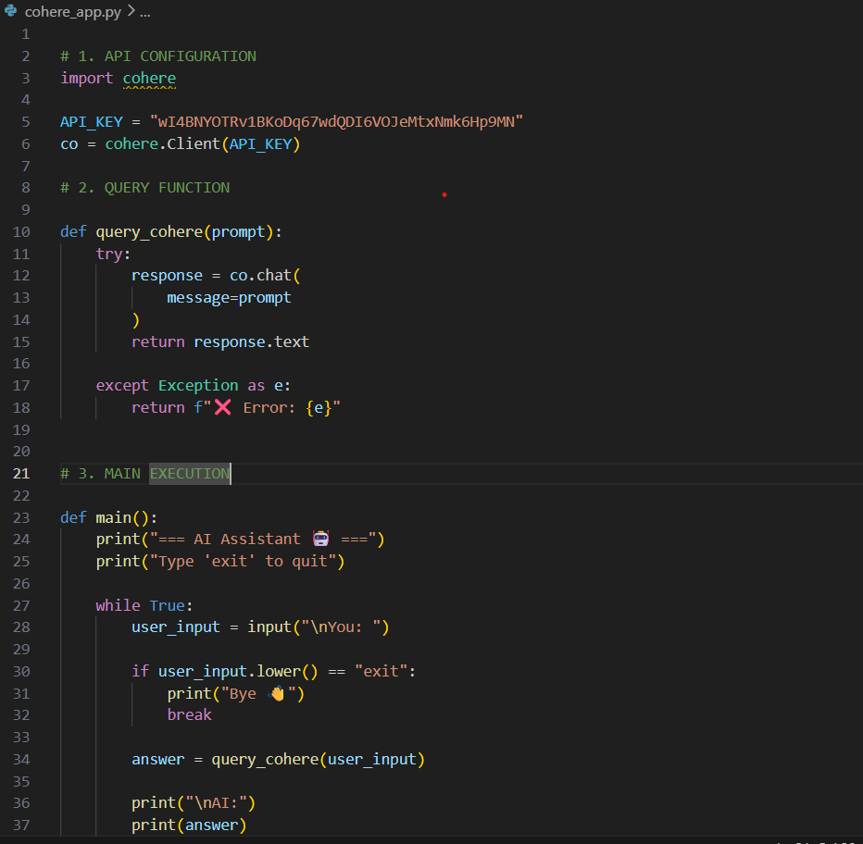
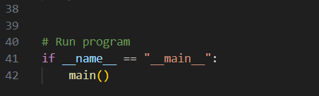

GROQ
Project Description
The program, groq_test.py, uses the groq Python library to send a user's question to their high-speed inference engine. I implemented a clean ask_ai function that handles the API request and added a basic try-except block to catch any connection errors or API issues.
Setup Instructions
To get this running yourself, here’s what I did:
- Python Setup: Make sure you have Python 3.8+ ready to go.
- Install the Groq Library: I used the official SDK. You can install it via pip:
pip install groq
- Add your API Key:
  - Open groq_test.py.
  - Find the client = Groq(api_key="...") line.
  - Swap out my key for your own personal Groq key.

How to Obtain a Groq API Key
If you need your own key, here is the process I followed:
- Go to the Groq Cloud Console.
- Sign in (I just used my Google account).
- Click on the "API Keys" tab in the sidebar.
- Hit the "Create API Key" button.
- Important: Copy the key immediately! Groq won't show it to you again after you close the pop-up.
How to Run the Program
Once you've saved your key in the script, just run it from your terminal:
python groq_test.py
- Usage: The program will ask: Enter your question:.
- Interaction: Type whatever you want to know and hit Enter.
- Output: The AI response will print out almost instantly.
Screenshots:
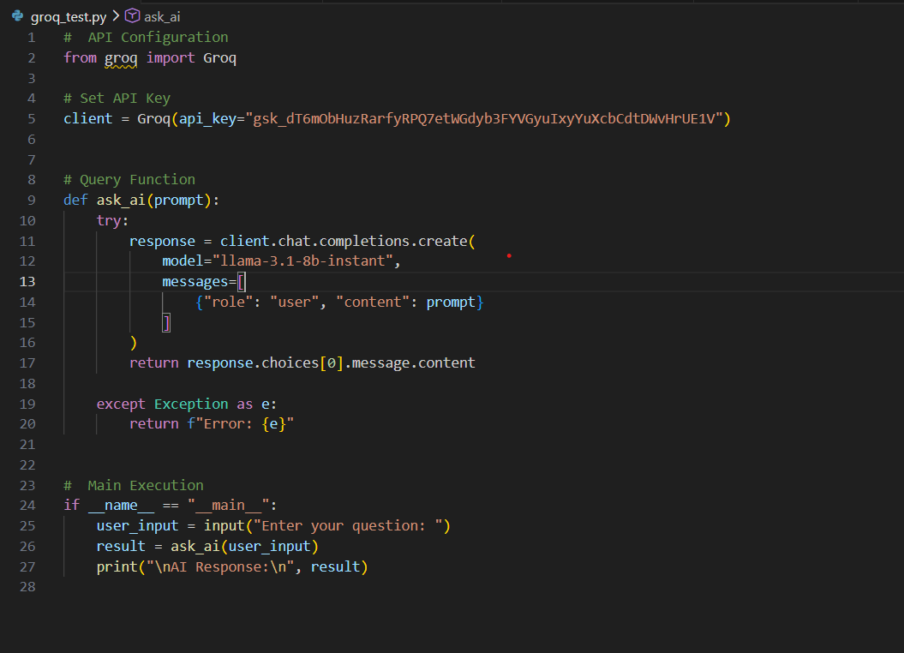

OLLAMA:
Project Description
The script ollama_example.py is a clean implementation of a local inference tool. I used the ollama Python library to communicate with a locally hosted Gemma:2b model. I chose the 2b version because it's lightweight and runs incredibly fast even on standard hardware.
The code is structured to take a user prompt, send it to the local Ollama server, and print the response directly to the terminal
Setup Instructions
To get this running on your local setup, follow these steps:
- Install Ollama: You need the Ollama desktop application installed and running in the background. You can get it from ollama.com.
- Download the Model: Open your terminal and pull the model I used in the script:
Bash
ollama run gemma:2b
- Install the Python Library: I used the official ollama package for this script. Install it via pip:
pip install ollama
How to Obtain the "API Key"
One of the best parts about this project? There is no API key. Since the model is running on your own computer, you don't need to sign up for a service, wait for an email, or worry about credit card limits. As long as the Ollama app is open, the script has everything it needs to function.
How to Run the Program
Once you have the gemma:2b model downloaded, just run the script:
Bash
python ollama_example.py
- The Flow: The script will ask you to Enter your prompt:.
- The Result: It will display "Querying API..." (meaning it's talking to your local server) and then print the AI's response.
Screenshots
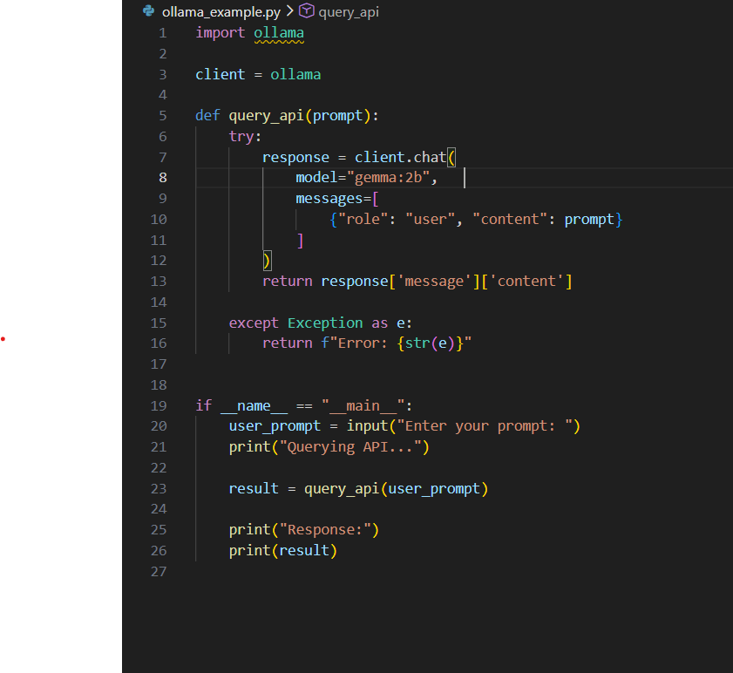

MULTIPLE API’s:
Project Description
The script multi_api_query.py acts as a central hub. I used a modular design where each AI provider has its own dedicated query function with built-in error handling. The main execution loop provides a simple CLI menu, letting the user toggle between models or exit the program gracefully.
Setup Instructions
To get this multi-provider setup running on your machine:
- Python Version: Ensure you are running Python 3.8 or higher.
- Install Requirements: You'll need both SDKs installed. Run this in your terminal:
Bash
pip install cohere groq
- Update Your Keys:
  - Open multi_api_query.py.
  - Look for the COHERE_API_KEY and GROQ_API_KEY variables at the top.
  - Paste your respective keys into those strings.

🔑 How to Obtain the API Keys
1. Cohere API Key
- Sign up at the Cohere Dashboard.
- Go to API Keys in the sidebar.
- Copy your Trial Key.
2. Groq API Key
- Go to the Groq Cloud Console.
- Sign in and click "Create API Key".
- Give it a name and copy the key (it won't be shown again!).
How to Run the Program
Start the master script from your terminal:
Bash
python multi_api_query.py
- Select a Brain: Type 1 for Cohere or 2 for Groq (Llama-3).
- Chat: Type your question and hit Enter.
- Exit: Type 3 to shut down the program.
Screenshots : 